CSC262 Java Programming – Module 2 Assignment

First Name | Marco
Last Name | Aliaga
ID# | 900946024
Assignment Week# | 2
Email Address | m.aliaga6024@student.nu.edu

How to submit your Assignment
After filling all the parts in this file, please follow the following steps.
- Add your name and ID to the first page.
- Save the file in the original format (Docx or Doc)
(Please do not convert to other file formats e.g. PDF, ZIP, RAR, …).
- Rename the file as
YOUR First Name - YOUR Last Name- YOUR student ID- CSC262.docx

Example:
John – Smith - 234566435 – CSC262.docx
- Upload the file and submit it (only using Blackboard)
Please do not hesitate to contact your instructor for CSC262, should you have any questions.

Problem 1: Data Analyzer
Write a program Data Analyzer that reads a set of floating-point values. Ask the user to enter the values, then print the following 4 values each in its own line with messages showing what each of the values is: (1) the average of the input value, (2) the smallest of the values, (3) the largest of the values, (4) the range, that is the difference between the smallest and largest. Enter anything other than a number to indicate the end of the value inputs.
Your code for this problem
import java.util.Scanner;

public class dataAnalyzer {

public static void main(String[] args) {

// Tell the user what this program does
System.out.println("This program analyzes a list of numbers.");
System.out.println("It finds the average, smallest value, largest value, and range.");
System.out.println("Enter anything that is not a number to stop.");
System.out.println();

// Create a scanner to read input
Scanner input = new Scanner(System.in);

// Variables to keep track of the numbers
double sum = 0;
int count = 0;
double smallest = 0;
double largest = 0;

// Ask the user to enter numbers
System.out.print("Enter a number: ");

// Keep reading numbers until the user enters something else
while (input.hasNextDouble()) {
double value = input.nextDouble();

// For the first number, set both smallest and largest
if (count == 0) {
smallest = value;
largest = value;
}

// Add the number to the total
sum += value;

// Count how many numbers were entered
count++;

// Update smallest if needed
if (value < smallest) {
smallest = value;
}

// Update largest if needed
if (value > largest) {
largest = value;
}

// Ask for another number
System.out.print("Enter a number: ");
}

// Only calculate results if at least one number was entered
if (count > 0) {
double average = sum / count;
double range = largest - smallest;

System.out.println();
System.out.println("Average: " + average);
System.out.println("Smallest value: " + smallest);
System.out.println("Largest value: " + largest);
System.out.println("Range: " + range);
} else {
System.out.println();
System.out.println("No numbers were entered.");
}

// Close the scanner
input.close();
}
}

Run the code and insert the result in the following box.
Sample Run Result
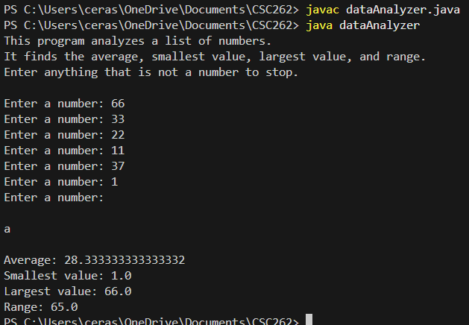

Problem 2: Character Counter
Write a program that reads a string and prints the most frequently occurring character and its frequency. If there are multiple characters that occur with the same maximum frequency, print them all. For example, if the word is mississippi, print
i (4)
s (4)
because i and s occur four times each, and no letter occurs more frequently. For simplicity, the input string consists of only lower-case characters.
Your code for this problem
import java.util.Scanner;

public class mostFreq {

public static void main(String[] args) {

// Tell the user what the program does
System.out.println("This program finds the most frequently occurring character(s)");
System.out.println("in a string of lowercase letters.");
System.out.println();

// Create a scanner to read input
Scanner input = new Scanner(System.in);

// Ask the user to enter a string
System.out.print("Enter a string of lowercase letters: ");
String text = input.nextLine();

// Create an array to count each letter (a to z)
int[] counts = new int[26];

// Count how many times each character appears
for (int i = 0; i < text.length(); i++) {
char letter = text.charAt(i);
counts[letter - 'a']++;
}

// Find the highest frequency
int maxCount = 0;
for (int i = 0; i < counts.length; i++) {
if (counts[i] > maxCount) {
maxCount = counts[i];
}
}

// Print all characters that have the highest frequency
System.out.println();
System.out.println("Most frequent character(s):");

for (int i = 0; i < counts.length; i++) {
if (counts[i] == maxCount) {
char letter = (char) ('a' + i);
System.out.println(letter + " (" + maxCount + ")");
}
}

// Close the scanner
input.close();
}
}

Run the code and insert the result in the following box.
Sample Run Result
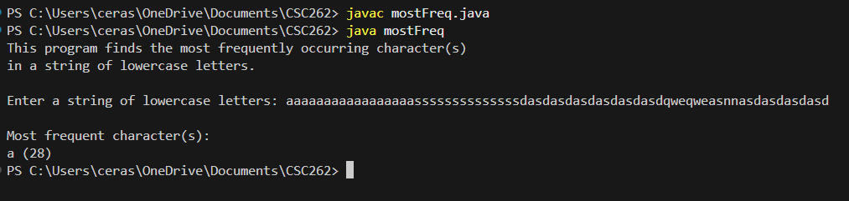

The end

